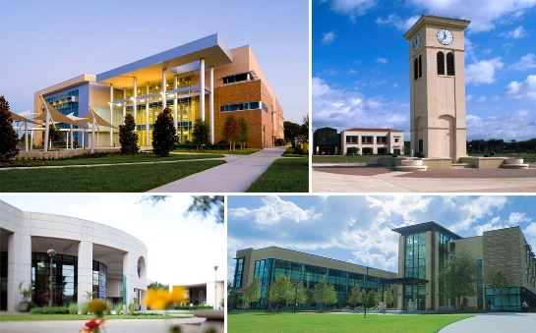

Degree Pathways at Valencia College
Valencia College primarily offers associate degrees, which fulfill the first 60 credits of a bachelor’s degree. Students can then continue to do one of the following:
- Earn a bachelor’s degree at Valencia College
- Transfer to any state college in Florida, or
- Transfer credits to many private or out-of-state colleges.
Benefits of Studying at Valencia College
- Osceola county high school graduates receive free tuition through the Osceola Prosper Scholarship
- Tuition is 40% less than at a Florida public university
- Guaranteed admission and priority access to the University of Central Florida through Direct Connect to UCF
- Transfer agreement with Florida’s 12 public universities (with a A.A. degree) including the University of Florida, Florida State University, and the University of South Florida
Degree Pathways Available

- Advertising/Public Relations
- Architecture
- Art, Studio/Fine Art
- Biology
- Chemistry
- Communications
- Computer Science
- Criminal Justice
- Dance Performance
- Dietetics (UF CALS)
- Digital Media
- Early Childhood Education
- Economics
- Elementary Education
- Engineering
- English
- Environmental Management (UF CALS)
- Environmental Studies
- Exploratory (Undecided)
- Food Science (UF CALS)
- Health Informatics and Information Management
- Health Sciences
- Health Sciences Administration
- History
- Horticultural Science
- Information Technology
- Journalism
- Mathematics
- Music Performance
- Natural Resources Conservation (UF CALS)
- Nutritional Sciences (UF CALS)
- Philosophy
- Physical Education
- Plant Science (UF CALS)
- Political Science
- Psychology
- Public Administration
- Secondary Education
- Sign Language Interpretation
- Social Sciences
- Sociology
- Statistics
- Theatre

